Pre & Post Test
Prepositions
Put in , on , under , in front of , behind , beside , between in the blanks.
The pen is …………….. the notebook. | The red ball is …………….. the dog.  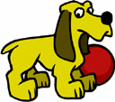
The brown dog is ………….. the box.  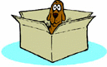 | The panda is …………………. the lamps.  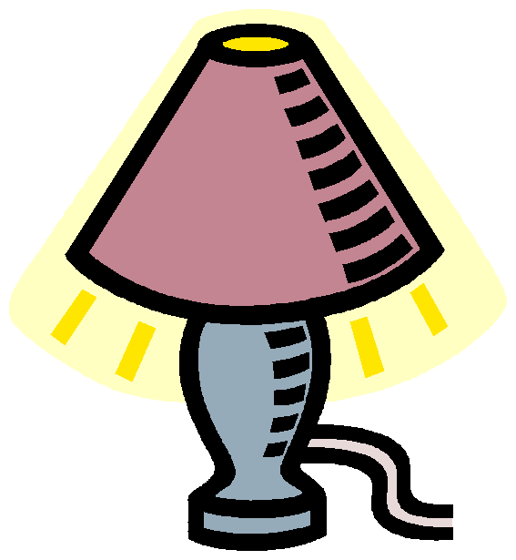
The apple is……………… the book and the pen. | The gray cat is ………………… the purple box.  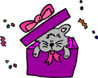
The pupil is ……………….the door.  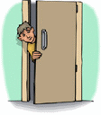 | The presents are ……………………… the table.  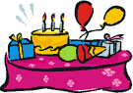
The girl is standing ……………….. the board.  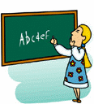 | Two people are ……………………..the green car.  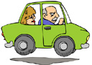
The pencil is ……………… the big red apple.  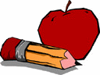 | The girl is reading …………………….. the chair.  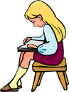
The chair is ……………….. the desk. | My brother is sitting……………………. the computer.
The ball is ……………. the box and the bear.  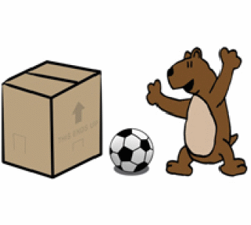 | Three pencils are ………………….. the pencil box.  